**Step 1:**

Open disc and view files. There will be versions of the Search tool on this disc. Open the “**Searcher**” file

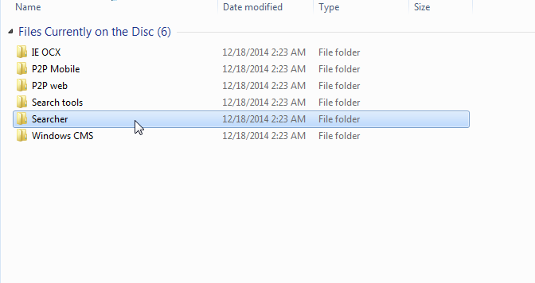

**Step 2:**

Once you have opened the “Searcher” file open the “**IPCSearch**” program.

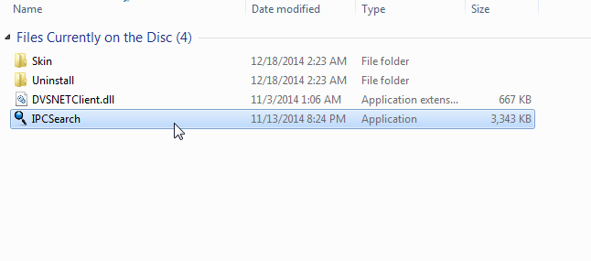

When opened the Search tool will look like this:

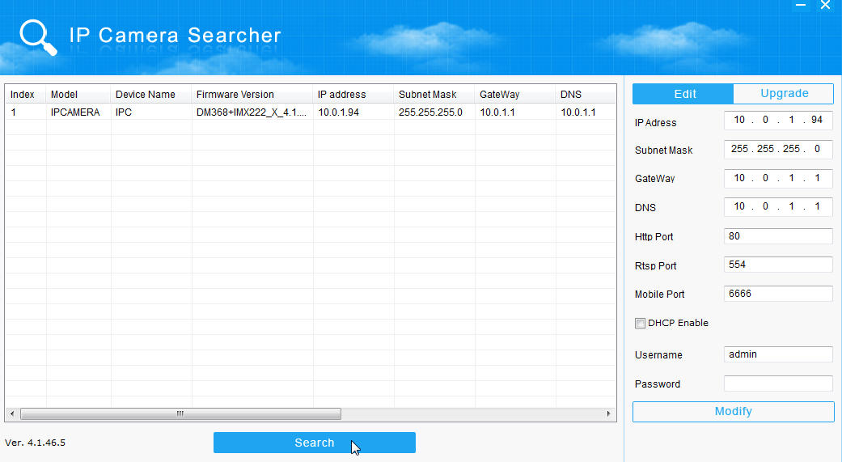

As you can see we already have a configured IP camera set up.

**Step 3:**

Click **Search** to find your new, non-configured IP camera.

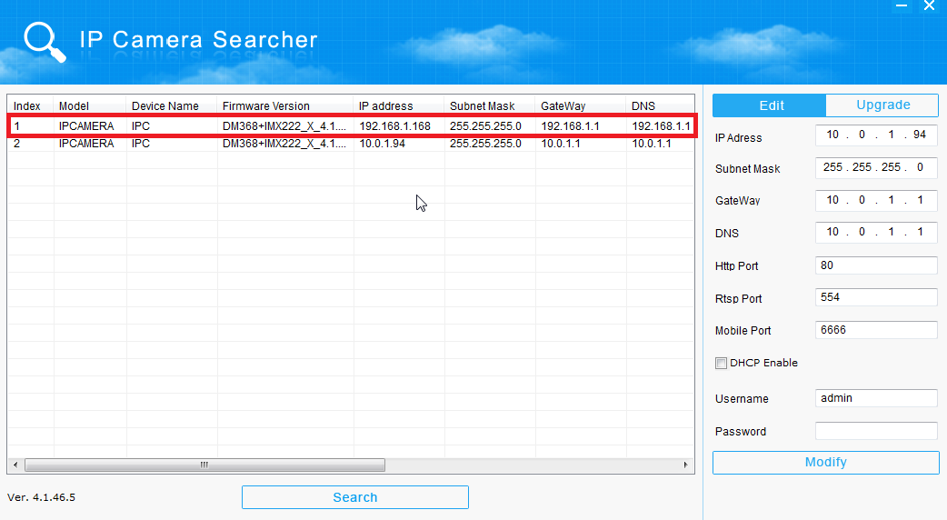

As you can see, the search tool has found the new camera with the initial factory settings.

**Step 4:** In order to change you IP Camera’s IP address you will need to first change your computer’s IP address.

If you try to change the IP camera’s IP address **BEFORE** you change your computer’s IP address you will get an error message:

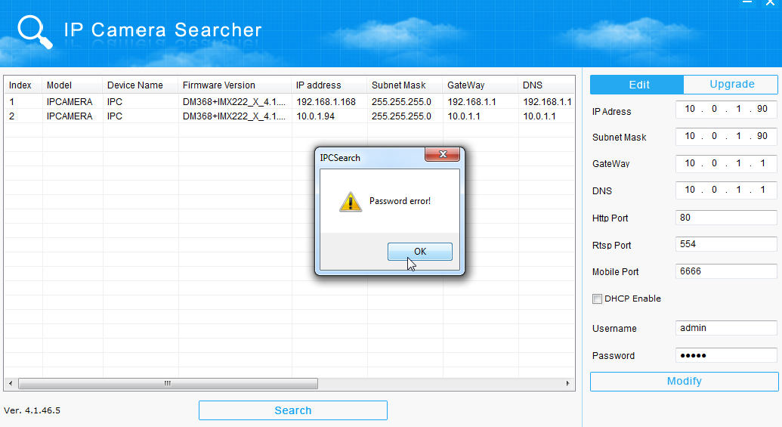

The error message will say “Password Error” this isn’t the actual error that is taking place.

What is happening is that your computer can’t log on to change the settings because it cannot access the camera when the computer and the camera are on different subnets.

A Subnet is the first three sections of an IP Address.

For example, if you computer’s IP address is **10.0.1.1,** your subnet would be: **10.0.1**

The last number is flexible. You can assign a device any number between 0-255

You CAN NOT put 2 devices on the exact same IP address.

**Changing your IP Address with Windows 7 Operating System**

1. In the Start menu search box, type: **ncpa.cpl**

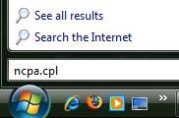

The Network Connections List appears.

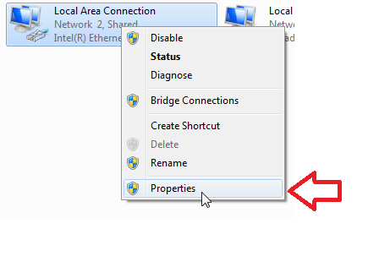

2. Right-click the **Local Area Connection** icon and click **Properties**.

3. In the **Networking** tab of the Local Area Connection Properties dialog box, click either **Internet Protocol Version 4 (TCP/IPv4)** or **Internet Protocol Version 6 (TCP/IPv6)**, and then click **Properties**

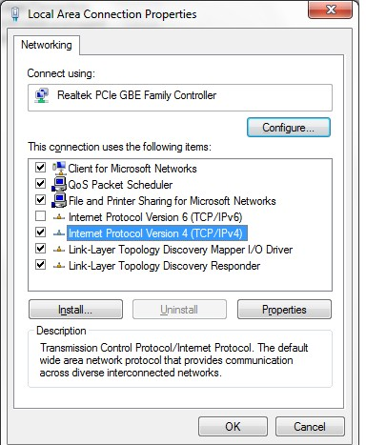

**Internet Protocol Version 4 (TCP/IPv4)**

**Properties Button**

4. In the **General** tab, click **Use the following IP address**, type the **CAMERA’S IP Address** in the **IP** **address** field. Click **OK** to save.

**Step 5:**

At this time your computer will disconnect from the internet. This is normal.

Go back to your Search Tool and you can now change your Camera’s IP Address.

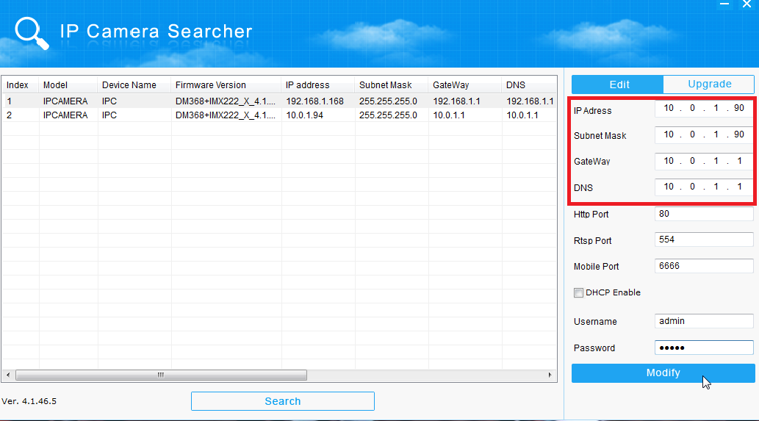

Make sure your camera has the correct **Subnet** and finish assigning its new IP Address.

To save, enter your username and password and click “**Modify**”

The search tool will not automatically refresh, you will need to click “**Search**” again for it to refresh and bring up the camera’s new IP Address.

To complete the setup, change your computer‘s IP Address back to its original address following the same steps in **Step 4.** Your computer will again disconnect from the internet for a few moments. Once your computer reconnects, you can go back to your Search Tool.

Now that your computer and IP Camera are on the same Subnet, you will be able to access and modify your camera through your computer and NVR that is on the same Subnet.